**1、ingress-nginx 相关**

|  |
| --- |
| Error from server (InternalError): error when creating "2.yaml": Internal error occurred: failed calling webhook "validate.nginx.ingress.kubernetes.io": failed to call webhook: Post "https://ingress-nginx-controller-admission.ingress-nginx.svc:443/networking/v1/ingresses?timeout=10s": dial tcp 10.99.153.145:443: connect: connection timed out |

**原因分析：**

我刚开始使用yaml的方式创建nginx-ingress，之后删除了它创建的命名空间以及 clusterrole and clusterrolebinding ，但是没有删除ValidatingWebhookConfiguration ingress-nginx-admission，这个ingress-nginx-admission是在yaml文件中安装的。当我再次使用helm安装nginx-ingress之后，创建自定义的ingress就会报这个错误。

**解决办法**

|  |
| --- |
| 1使用下面的命令查看 webhook  kubectl get validatingwebhookconfigurations #    2删除ingress-nginx-admission  kubectl delete -A ValidatingWebhookConfiguration ingress-nginx-admission |

重新部署

#k apply -f whoami-ingressroute.yaml

<https://blog.csdn.net/qq_39218530/article/details/115372879>

**2、使用Kubeadm安装的K8s集群获取kube-scheduler和kube-controller-manager组件状态异常问题**

|  |
| --- |
| Warning: v1 ComponentStatus is deprecated in v1.19+  NAME STATUS MESSAGE ERROR  controller-manager Unhealthy Get "http://127.0.0.1:10252/healthz": dial tcp 127.0.0.1:10252: connect: connection refused  scheduler Unhealthy Get "http://127.0.0.1:10251/healthz": dial tcp127.0.0.1:10251: connect: connection refused  etcd-0 Healthy {"health":"true"} |

vim /etc/kubernetes/manifests/kube-scheduler.yaml

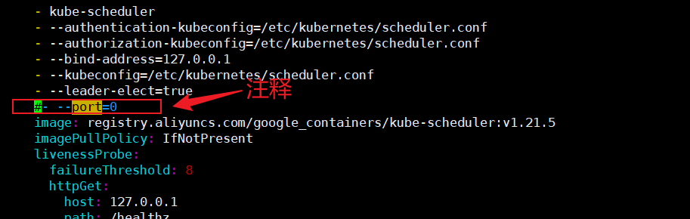

vim /etc/kubernetes/manifests/kube-controller-manager.yaml

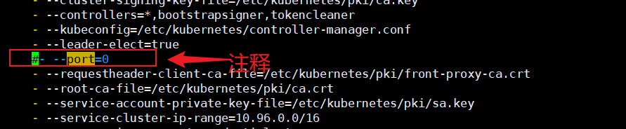

重启kubelet

systemctl restart kubelet

检查

kubectl get cs

